1.

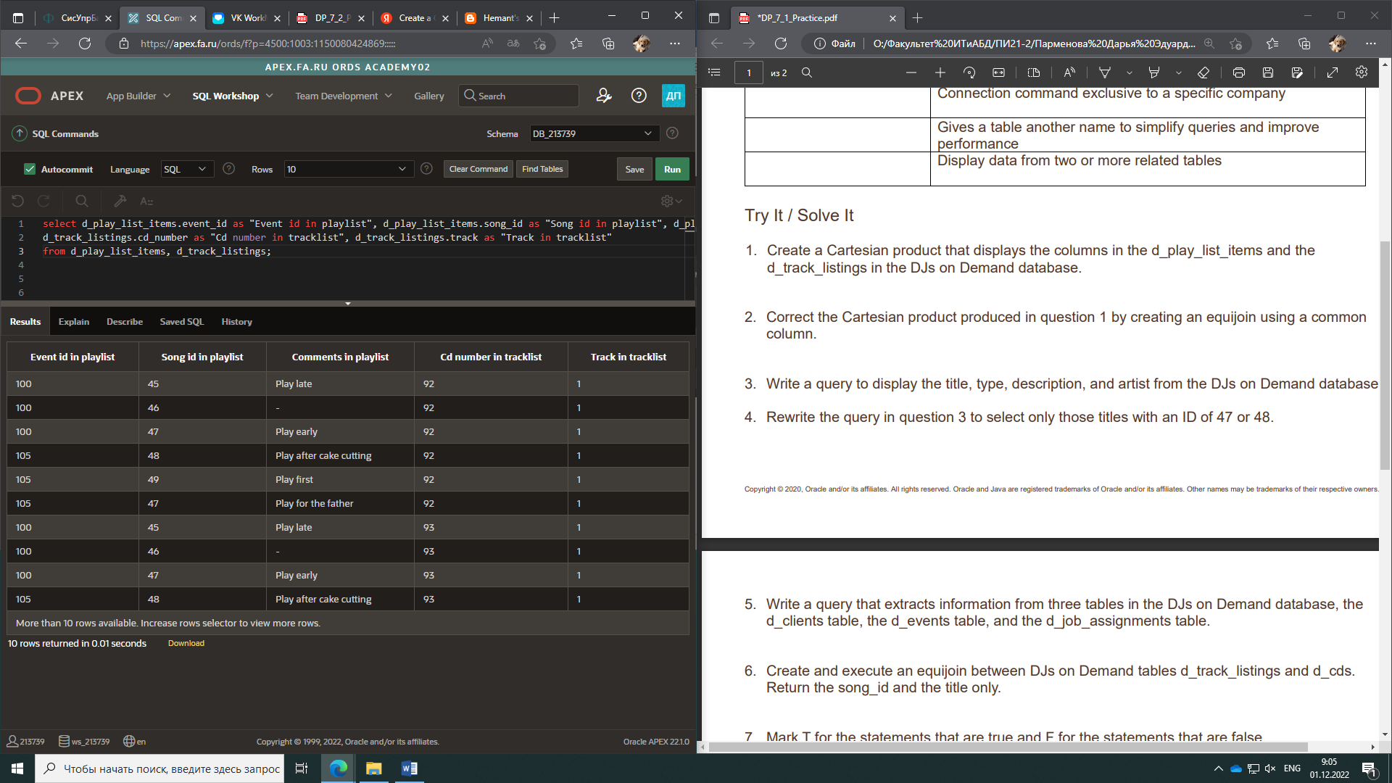

2.

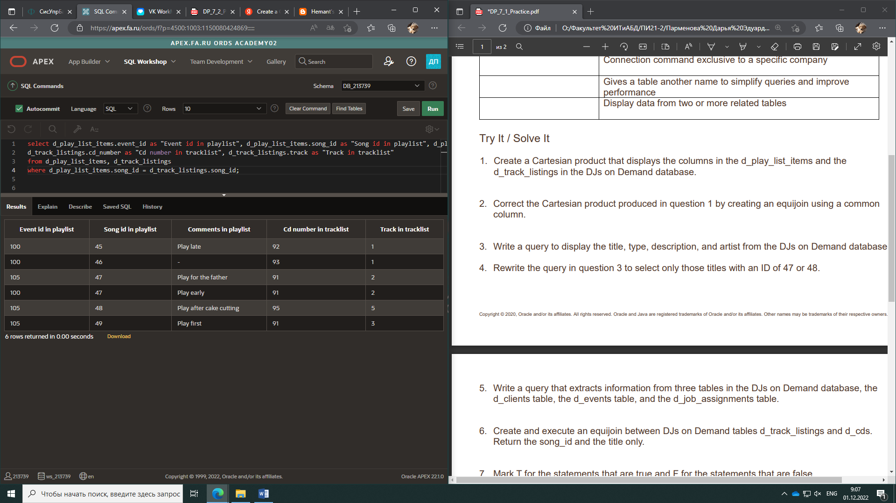

3.

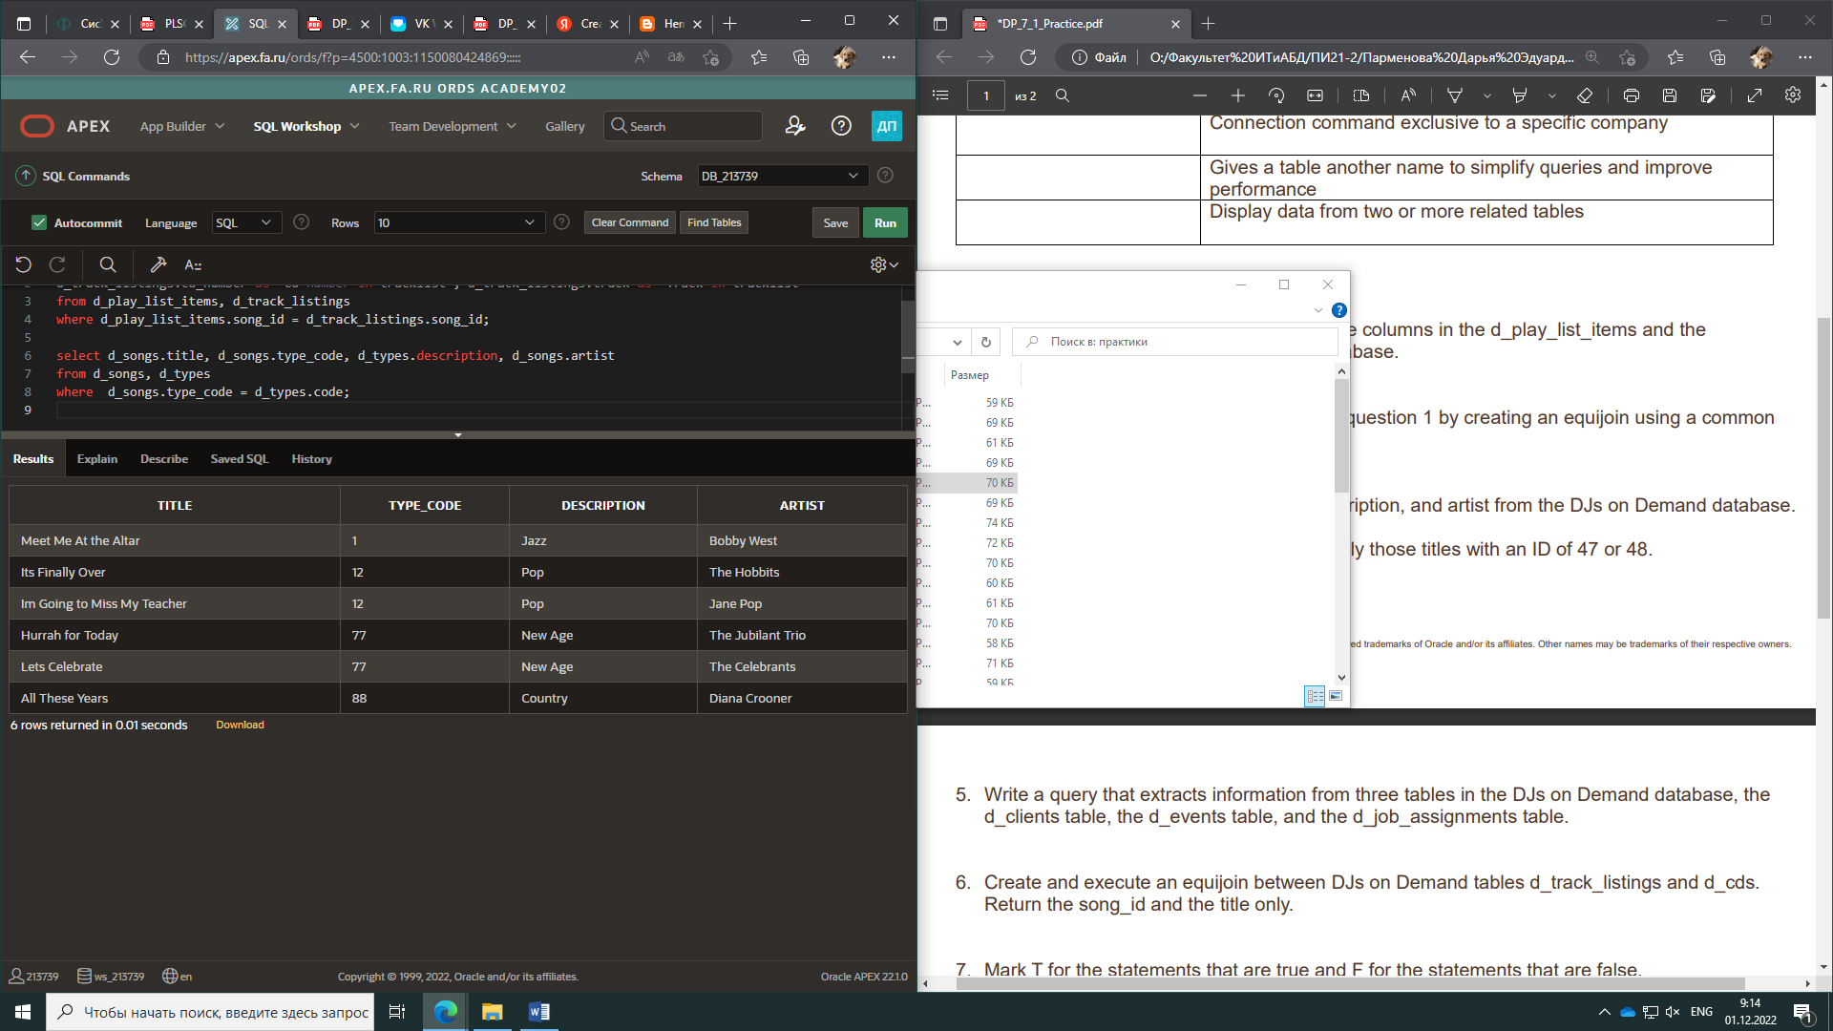

4.

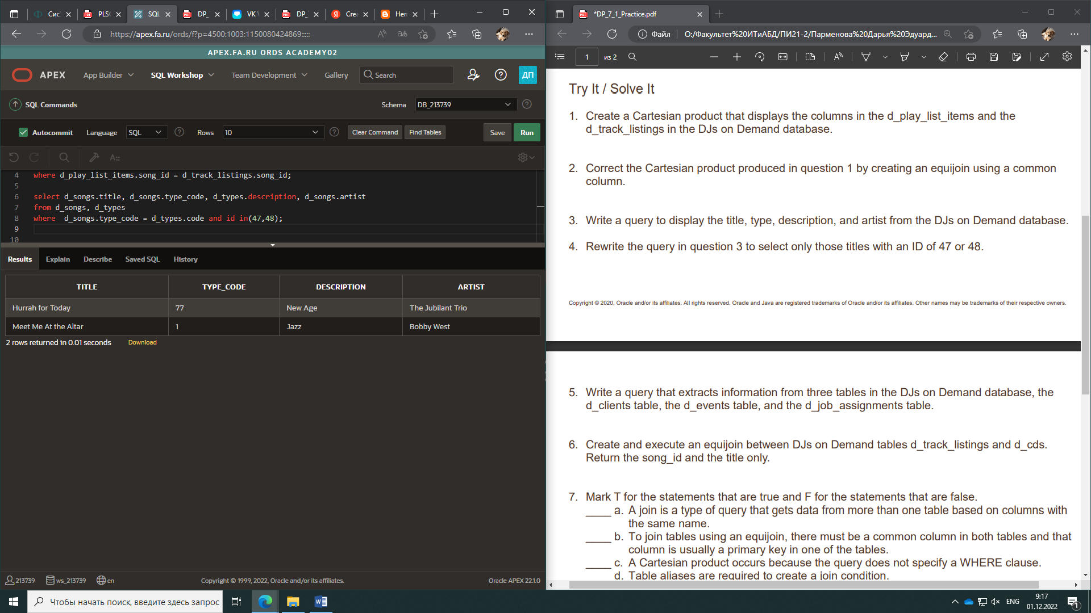

5.

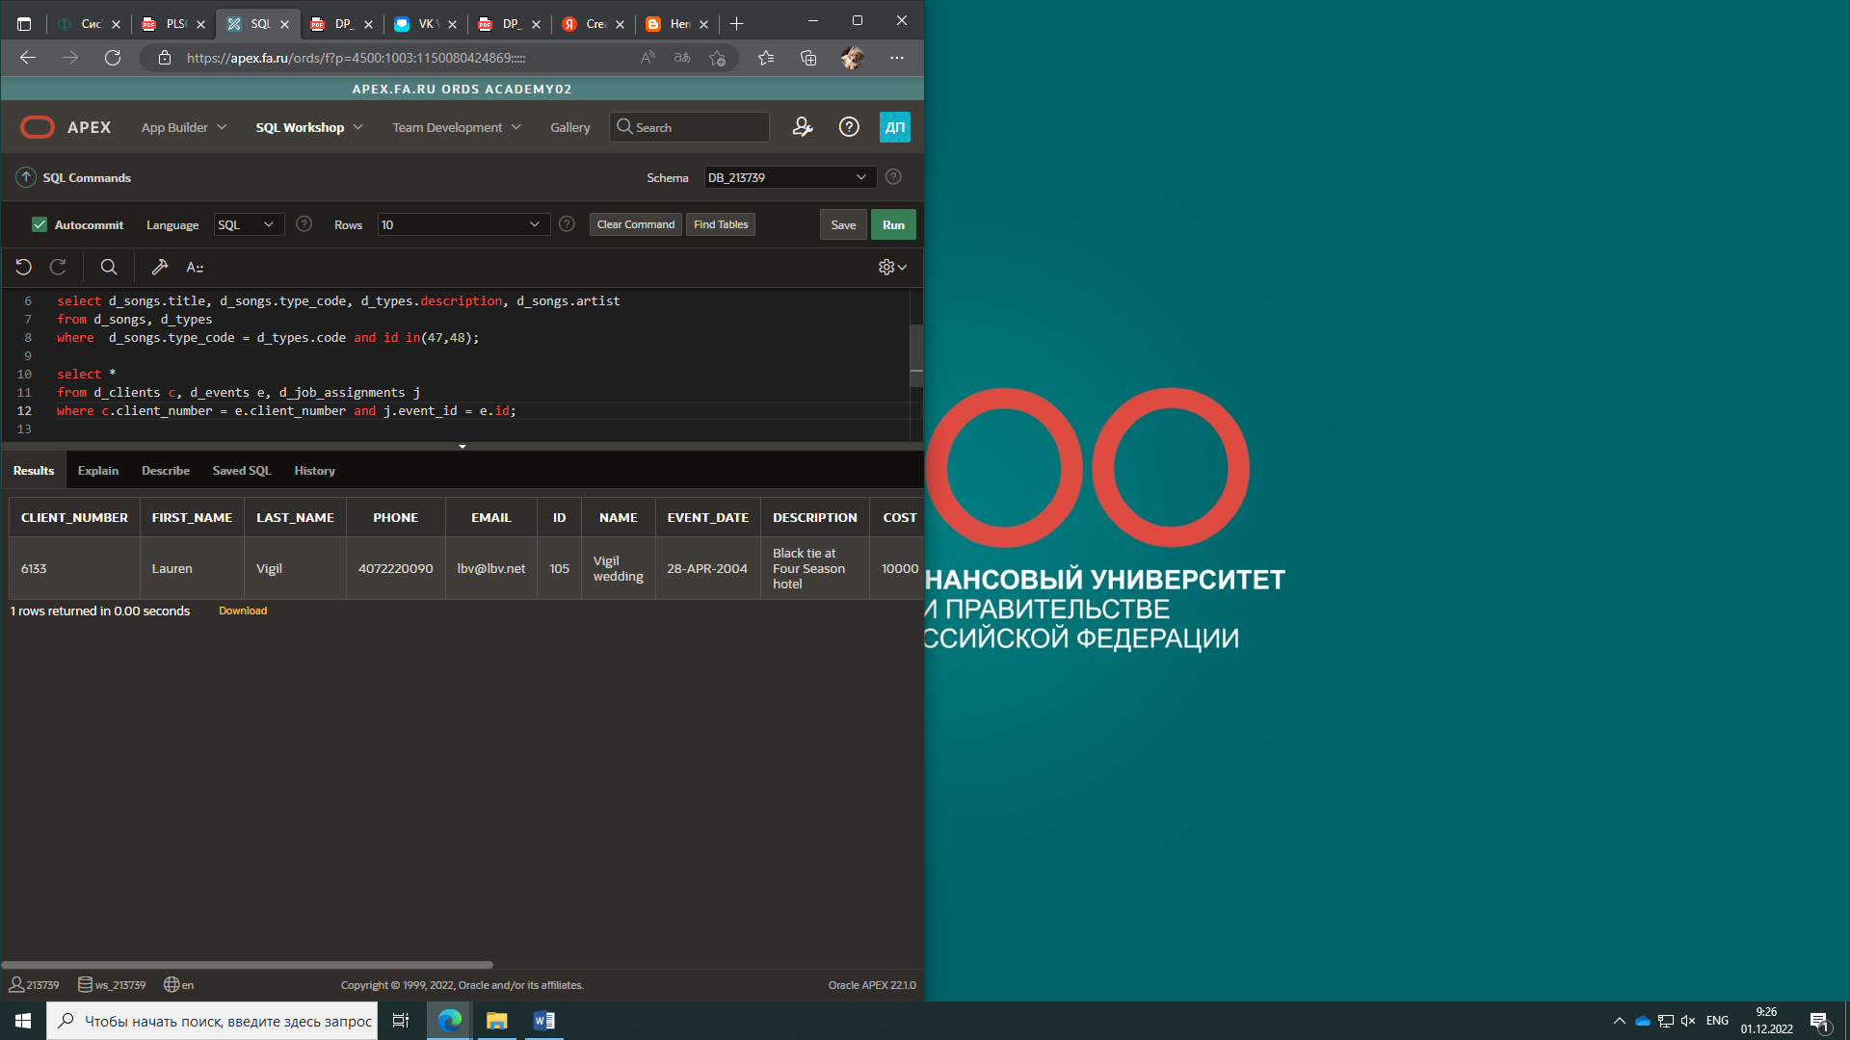

6.

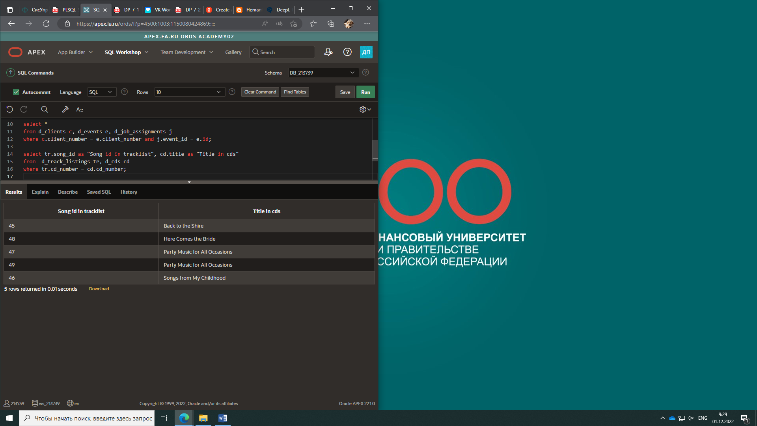

7.

**F** a. A join is a type of query that gets data from more than one table based on columns with the same name.

**T** b. To join tables using an equijoin, there must be a common column in both tables and that column is usually a primary key in one of the tables.

**T** c. A Cartesian product occurs because the query does not specify a WHERE clause.

**F** d. Table aliases are required to create a join condition.

**T** e. If a table alias is used for a table name in the FROM clause, it must be substituted for the table name throughout the SELECT statement.

**F** f. Table alias must be only one character in length.

**T** g. A simple join or inner join is the same as an equijoin.